

**American International University- Bangladesh**

**CSC 3215: Web Technologies**

**CO2 and CO4 Evaluation**

**Finished Project Report**

**Summer: 2020-2021**

**Project Title: G-9 Book shop.**

**Section: F**

|  |  |
| --- | --- |
| Student Name | Student Id |
| Syed Ashraful Alam | **17-33574-1** |
| MD. Shazib Sheikh | **18-36278-1** |
| Syfur Rahamn | **18-37072-1** |
|  |  |

**Project: G-9 Book Shop**

**Introduction:**

The internet has transformed the world into a global village that is making our lives much more accessible. Shopping is a vital component of real-world activity that has made its way onto the internet. During Covid-19 and the lockdown situation, online shopping websites have grown in popularity. Among them, online book shopping comprises the purchase and sale of a wide range of books, with the buyer making his book selection and paying via the internet.

**Motivation and background study:**

Reading books is an easy way to take care of our mind and body by reducing stress, reducing age-related cognitive decline, and increasing peace of mind. Famous writer Charles W. Eliot once said, "Books are the quietest and most constant of friends; they are the most accessible and wisest of counselors, and the most patient of teachers." Because of the current Covid 19 and lockdown situation, it has become very difficult to buy books from a shop physically. So, here comes the concept of our online book shop project, which is an integrated management system that handles many aspects of a book shop's workflow. It manages the flawless operation of buying and selling a wide range of books, timely delivery, and administrative and financial monitoring. Our G-9 Book Shop Project covers the services that unify and simplify the activities of book shops and their interactions with buyers.

**Project Description:**

Our G-9 Book shop project website has some special innovative features. Admins and all users can sign up or register on the system, and it records the general information about them, such as name, email, phone number, address, profile picture, etc., into its database. If an administrator or user wishes to access the website, they must first log in to the system, and the system will then validate the information they submitted from the database. After successful validation, the user can access many books from different categories and buy the books they want. On the other hand, the admins can maintain the whole website and perform the "CRUD" operation. We have implemented CSS, JavaScript Validation, JSON, PHP Validation, Session, Ajax in this project.

**Conclusion:**

We made every effort to design a simple, user-friendly website from which our society's citizens can benefit. Our G9 book shop website makes people's lives very easy as they get whatever books they desire at a very affordable price, all with just a few clicks.

**Project Folder Structure:**

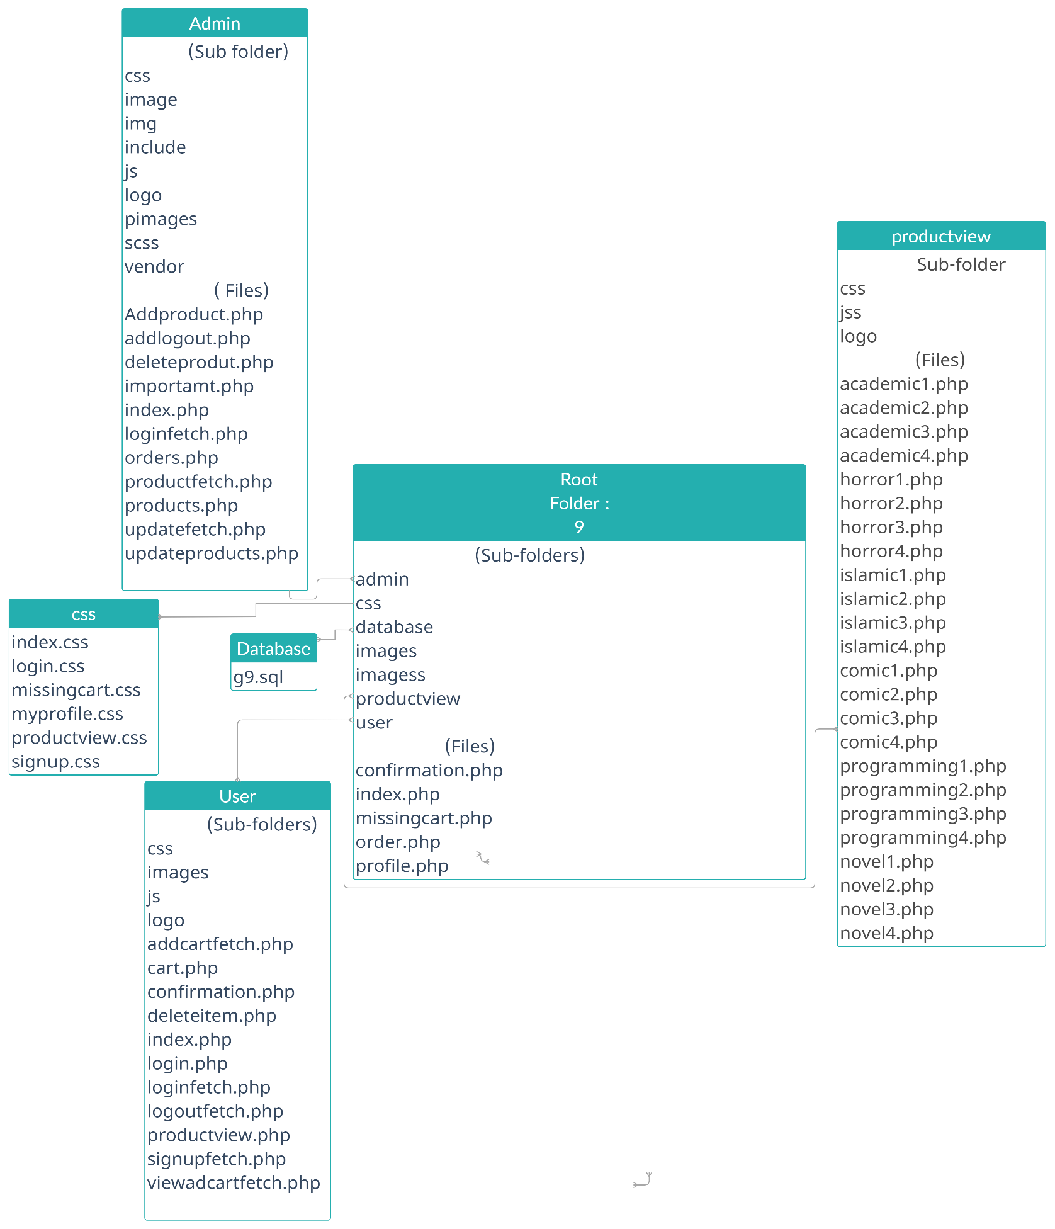

***login.php***

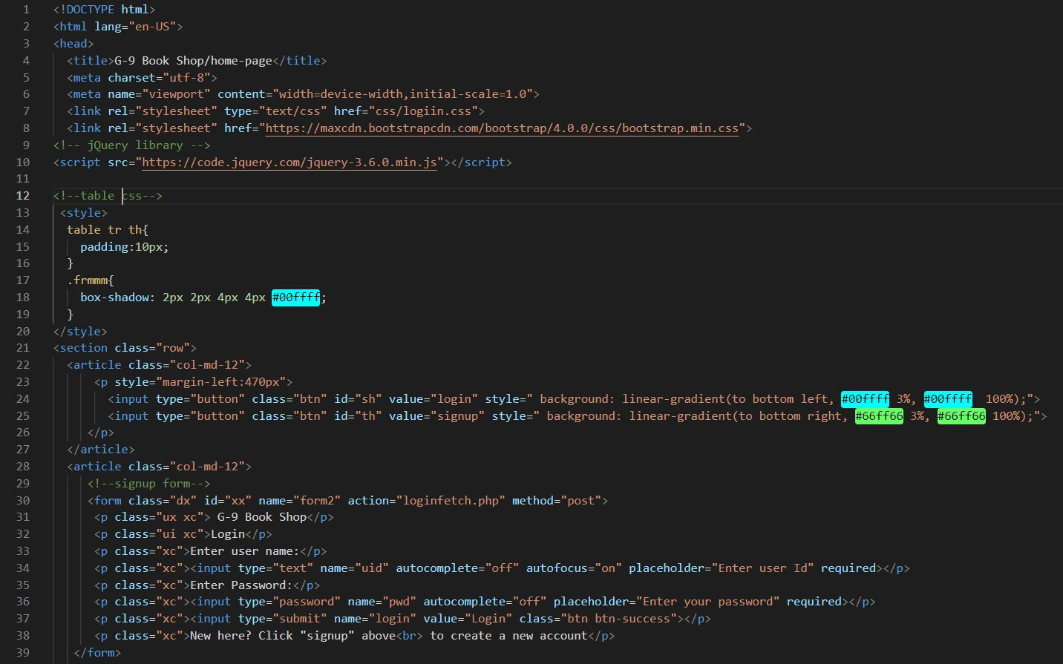

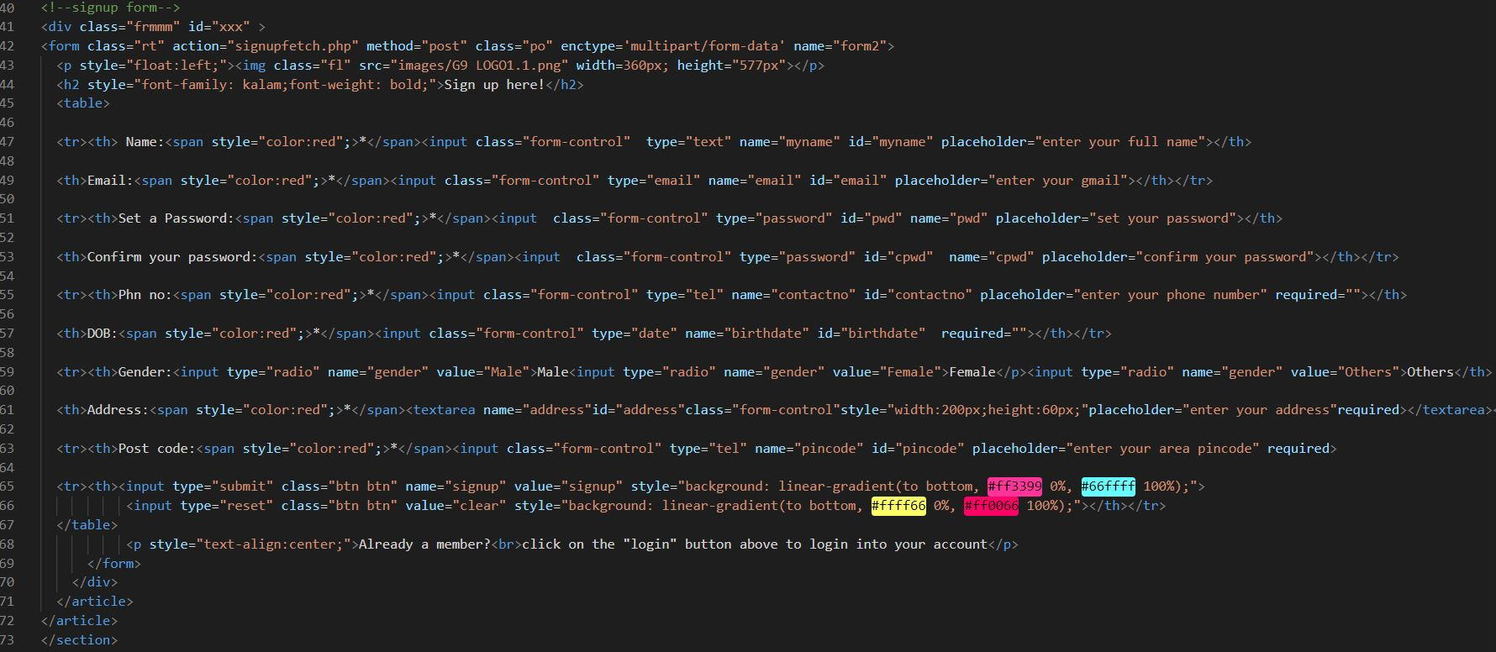

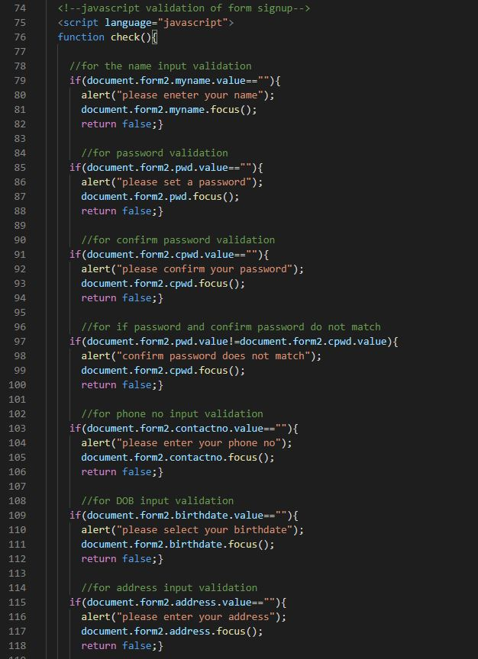

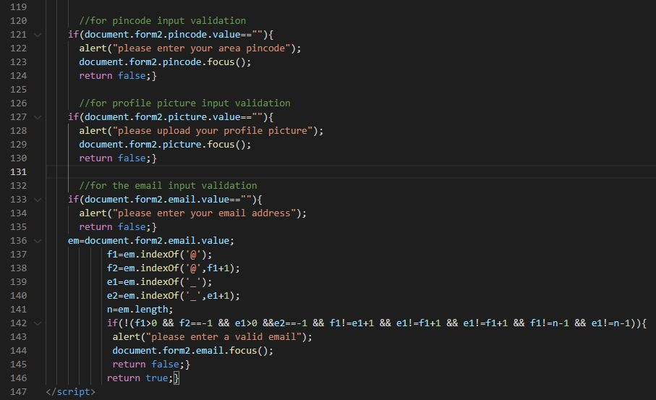

***product.php***

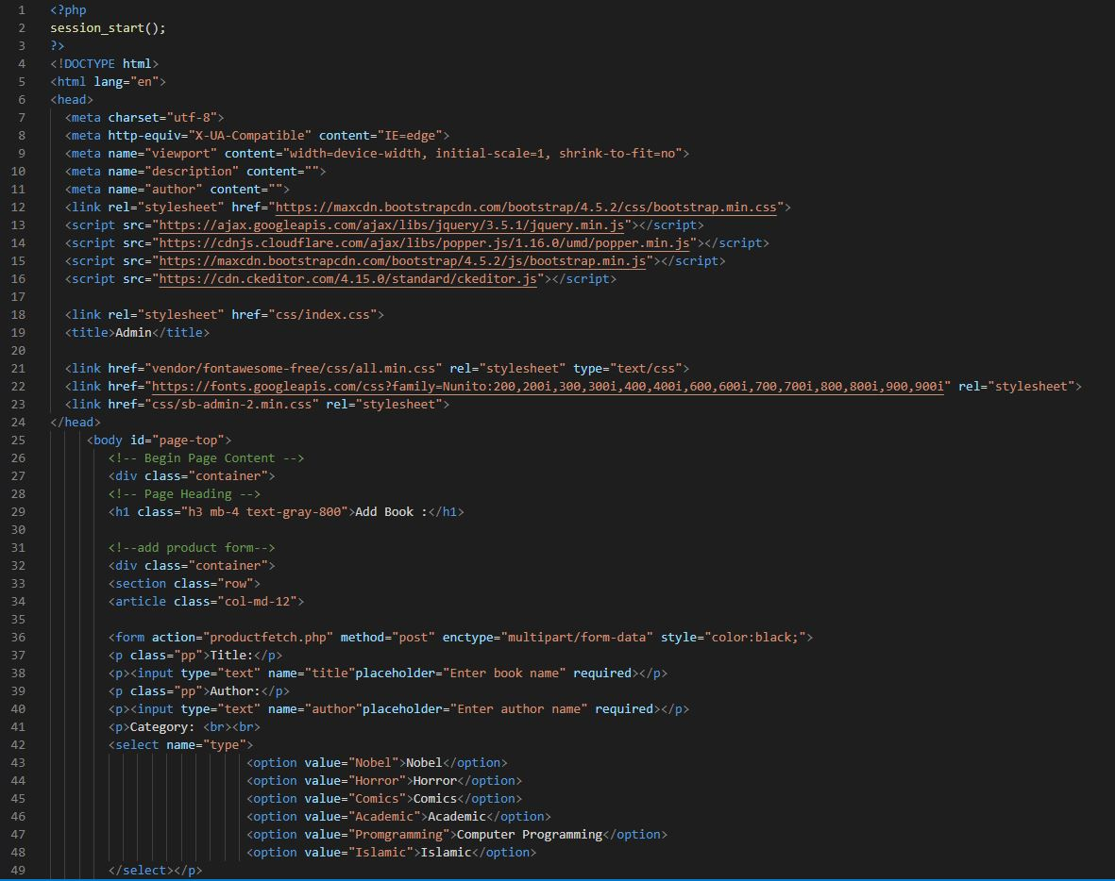

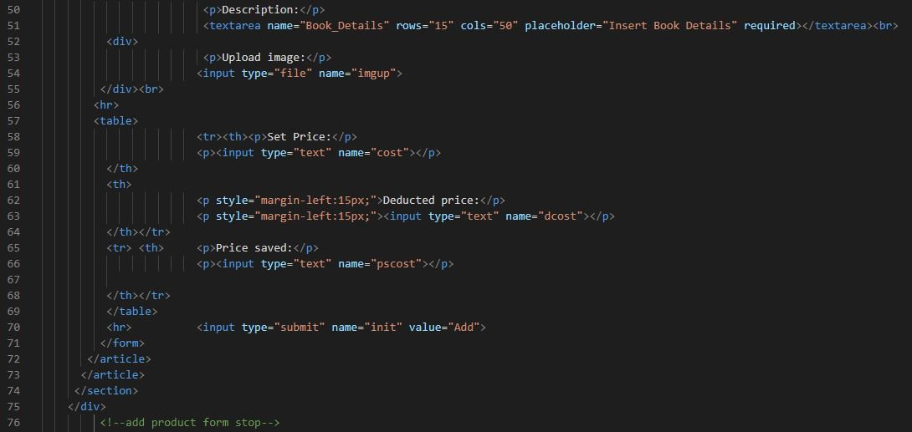

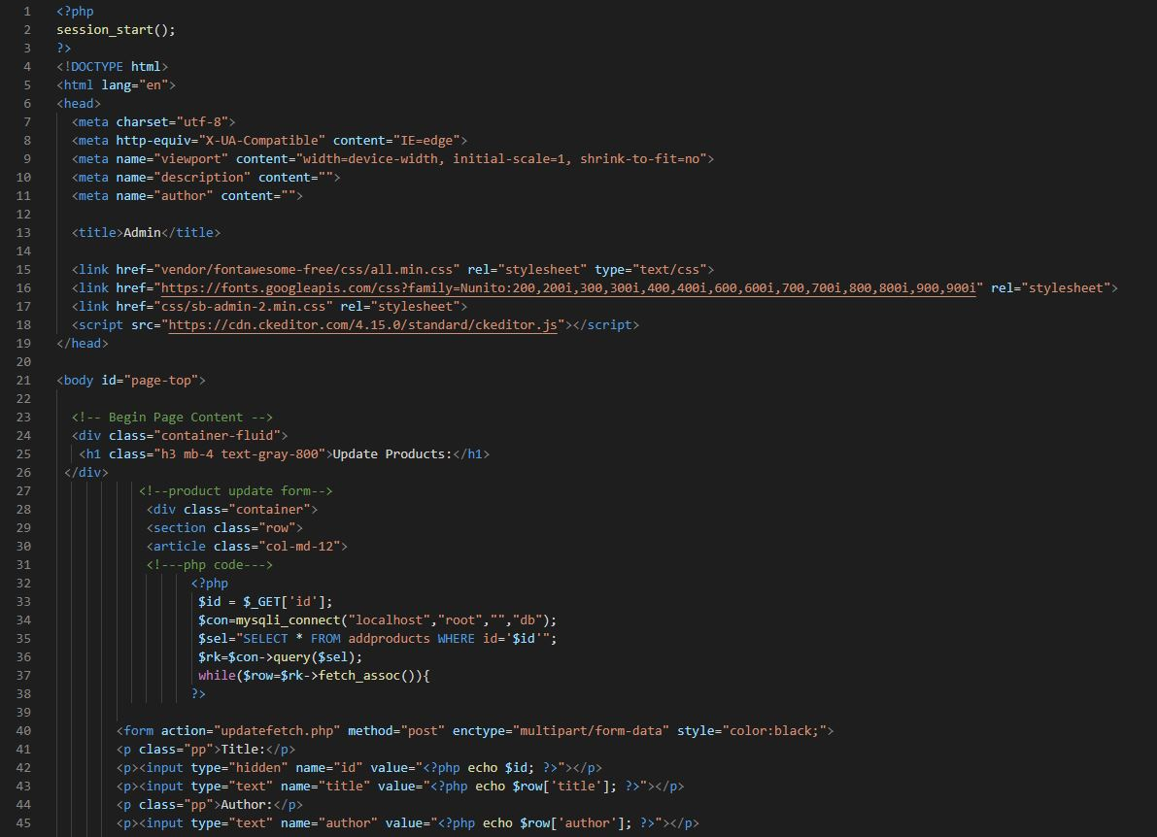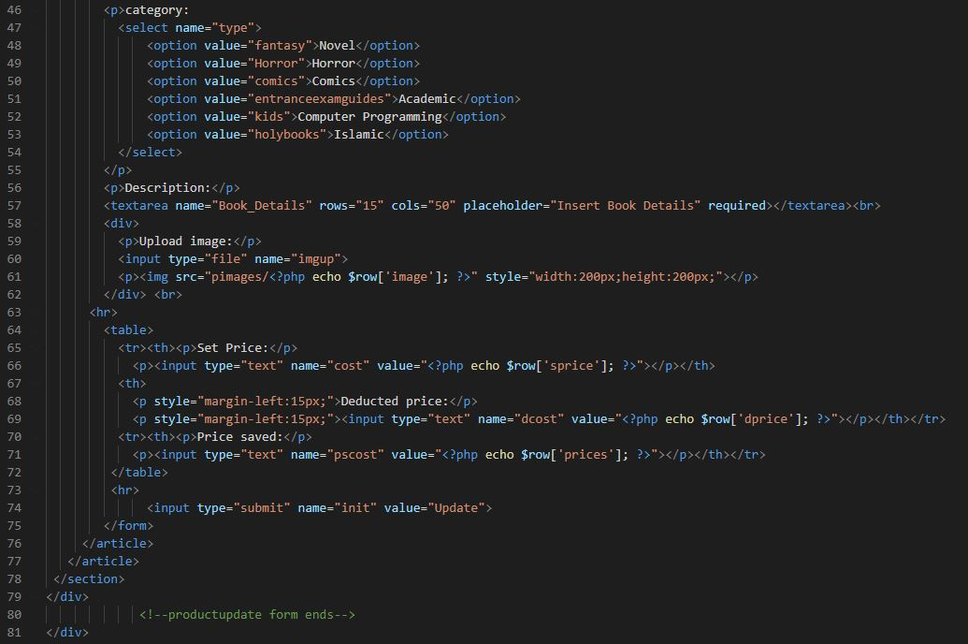

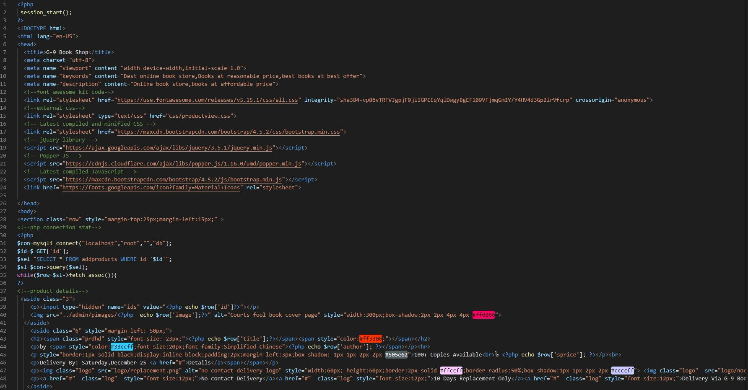

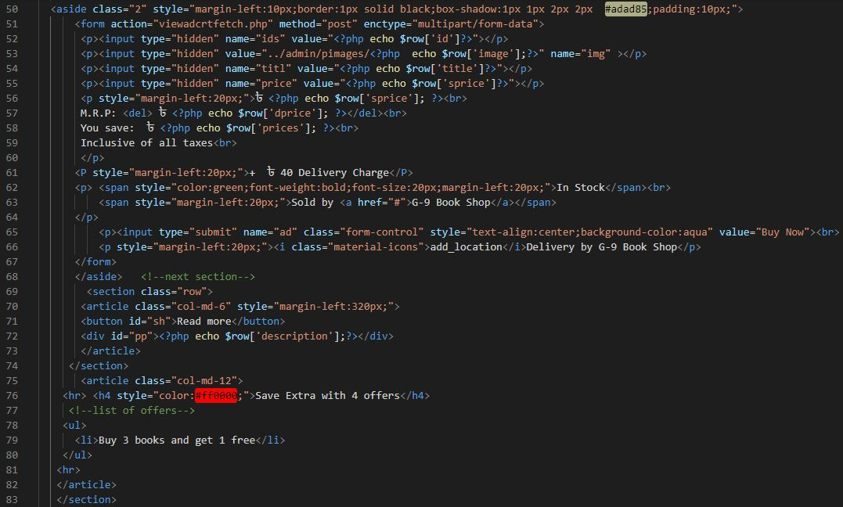

***Cart_and_order.php***

